**Introduction.**

This is a report that refers to the Helpdesk database and assesses its technical suitability in terms of data security, availability and integrity. It makes recommendations where required.

**Database Security.**

“Data is a valuable resource that must be strictly controlled and managed, as must any corporate resource. Part or all of the corporate data may have strategic importance to an organization and should, therefore, be kept secure and confidential.” [1]

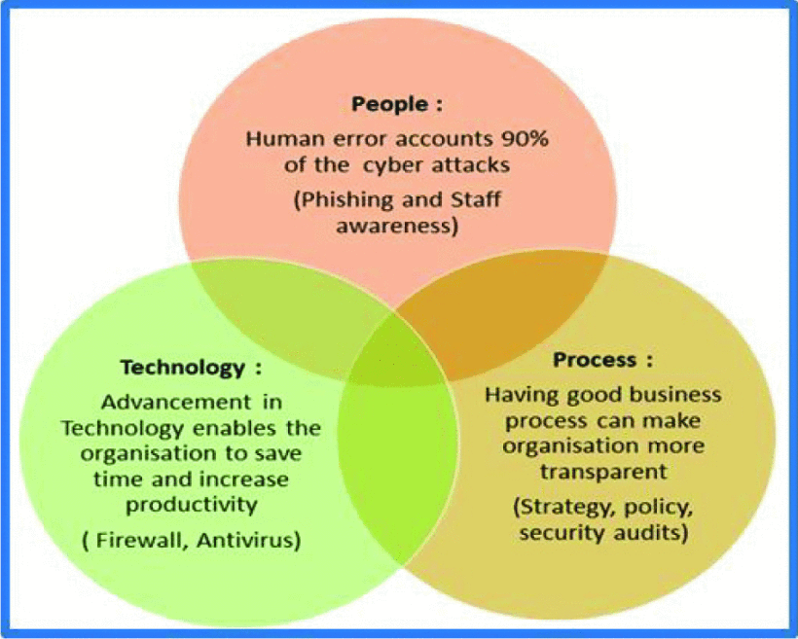

Fig 1.0 [2]

A SWOT analysis [3] was carried out by the Helpdesk development team. Top rating Threats [4] of SWO**T** were broken out into Tables 1A/B with Overall Consequences levels assigned.

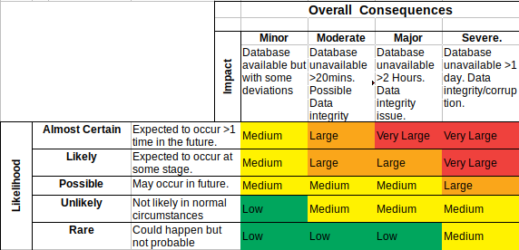

Table 1A

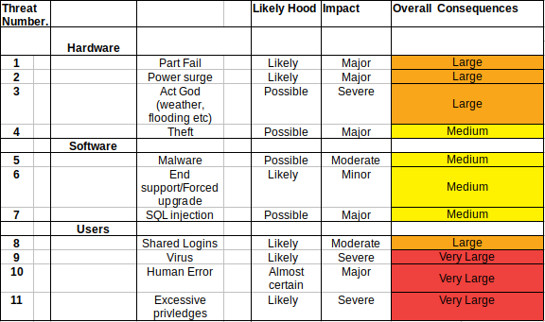

Table 1B

Oracle provides two types of security, [1] [5];

**System security** – access to the database for authorized users only [1].

The Helpdesk features both Apple and Microsoft OS. Both feature 2FA [6,7] through phone/email and this was considered as a method to authenticate from the OS to Oracle.

The risk here is that updates to the OS or newly added equipment that does not support this feature would render the database inaccessible.

The Helpdesk is an internal system (not public-facing) that has just employee access. Oracles own stand-alone database authentication can be used and includes;

Password Encryption, Account Locking, Password Lifetime, Expiration +Complexity Verification [5].

Point 8, table 1B is still relevant but this can be mitigated against in company security policies.

**Data security** – through Discretionary access control (DAC) [8].

This section addresses Threat point 11.

DAC can be used to give specific access privileges based on users needs.

While it is possible to set each user privileges individually Oracle supports CREATE ROLES [9]. A user is assigned to a ROLE, each ROLE is GRANTed [10] privileges.

Roles in the Helpdesk can be assigned as Table 2.

We can create a user using SQL;

CREATE USER user1 IDENTIFIED BY password

DEFAULT TABLESPACE users

TEMPORARY TABLESPACE temp;

We can assign the Manager ROLE to user1 to a ROLE using

GRANT Manager TO User1;

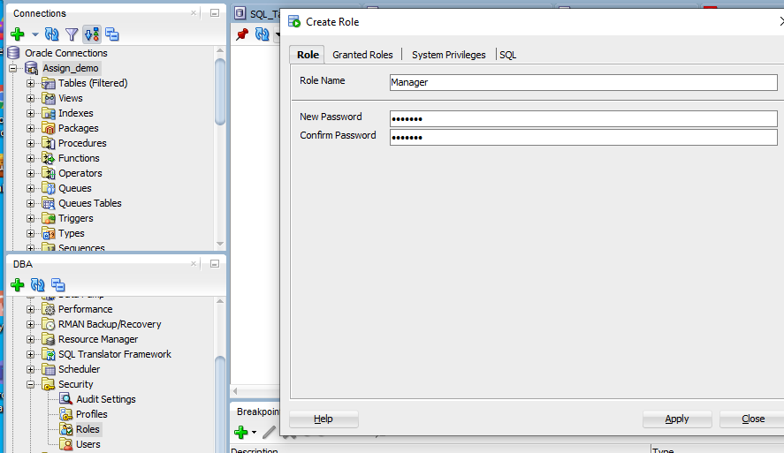

Fig 1. Creating a Manager role through DBA GUI in SQL developer.

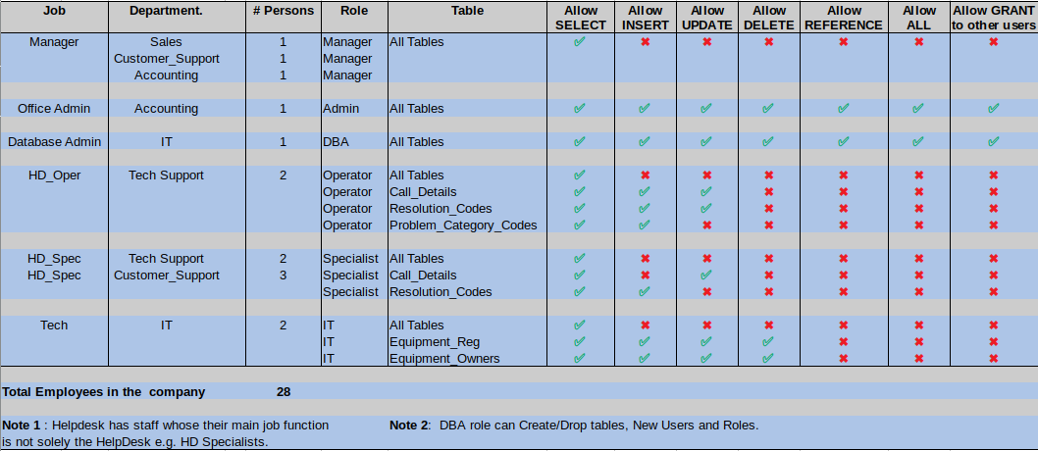Table 2.

**Views:**  Used to restrict access both user access to a view and restricted column view of table. Mangers are the ideal group in the Helpdesk to set up views for, as they typically are not altering information in the database. A recommendation here is that the information managers are interested in, have views created. Direct table access privileges can then be REVOKEd. This helps with threat point 11.

**Input Validation and Sanitization** [11]; (Threat points 7, 10). The Helpdesk database does not check all data input from the user is valid and so is open to SQL injection attacks[12]. These recommendations from Oracle [13] should be implemented as a minimum. This also helps to maintain data integrity.

**Data Integrity: (**Threats 1-4, possibly 5,7,9 &10 ) To recover the database after a failure we need to know that all transactions were completed and data integrity maintained before the failure.

**Concurrency Control:** In a multi-user database we need to prevent data being updated by one user while it is being queried by another user. (See Dirty, Non-repeatable & Phantom reads [14). One way to do this is to run transactions serially i.e. one transaction cannot start until the previous transaction is complete. This, however, is not practical as it severely limits throughput. [14] It would be possible to add a ‘Lock’ column to each table and setting that attribute to flag shared (perhaps a number >0 for the number of shared locks active ) or exclusive lock (e.g. -1). Transactions could then check the attribute lock state before running the query/update. See [1] PP683. Fortunately, Oracle maintains locks automatically in two different ways. Read Committed and Serializable Isolation [14]. There is a trade-off in terms of concurrent users vs data read consistency. See Table 3 [14].

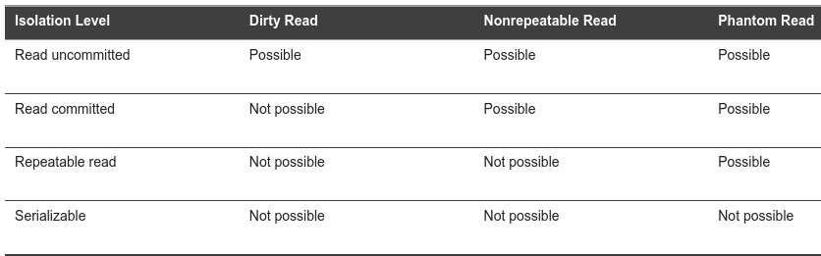Table 3.

For the HelpDesk we can set serialisation using;

SET TRANSACTION ISOLATION LEVEL SERIALIZABLE;

As there are only some users with INSERT/UPDATE privileges we have gone for data consistency. An error will results if there are serialisation conflicts and as there are a low number of users are located in the same office, this can be resolved locally. [14]

**Backup** [15]**.**

Oracle recovery manager (RMAN) [16] can be used to perform automated backups and recovery.

**Keeping up to date:** Oracle uses redo logs and a control file to document changes in the DB since the last back-up. These files are then used to rebuild the database during recovery.

As the HelpDesk only runs 8 hours a day and Mon-Fri it is acceptable to schedule cold backups (incremental at night and full back-ups at the weekend). Oracle also supports check-pointing [17] which is set automatically.

Also using separate RAID 1+0 storage configurations for data and log+control files is the recommendation from Oracle [18] and offers mirroring/redundancy + speed. This should allow automatic roll-over in the event of a single disk failure. In a sense, the redo log files can be thought of as differential file recovery strategy but in the true differential file recovery strategy log files are updated periodically in batch form which is not the case here.

**Recovery** [15]: The concept of deferred update technique where transactions write to the log files before committing to the database can be implemented. Other techniques such as shadow paging would negate the requirement to journal log files but this is offset by the need to run background tasks to deal with things like data fragmentation. [1]

RMAN can provide automated for some types of failures i.e. program and instance failures. Incorrect data or media failure (if not caught using roll-over) may require human intervention and could still be problematic to solve.

**Conclusion:** Whilethe HelpDesk is not a large or highly utilised database it still needs to be configured with security and back-up in mind. This report deals with many of the initial concerns but security is an ongoing process and so further updates and auditing[19] are needed at regular intervals in order to maintain database business requirements.

**References.**

[1] T.M, Connolly; C.E, Begg, Database Systems - A Practical Approach to Design Implementation and Management, pp607-696, 709 Pearson Education, 2015.

[2] A. H. Khan, P. Bahl Sawhney, S. Das, and D. Pandey, ‘SartCyber Security Awareness Measurement Model (APAT)’, in 2020 International Conference on Power Electronics IoT Applications in Renewable Energy and its Control (PARC), Feb. 2020, pp. 298–302, doi: 10.1109/PARC49193.2020.236614

[3] ‘ProjectManagement.com - SWOT Analysis’. <https://www.projectmanagement.com/wikis/233091/SWOT-Analysis> (accessed Nov. 07, 2020).

[4] ‘Database Security: An Essential Guide’, Dec. 13, 2019. <https://www.ibm.com/cloud/learn/database-security> (accessed Nov. 06, 2020).

[5]‘Database Concepts’. <https://docs.oracle.com/cd/B19306_01/server.102/b14220/security.htm> (accessed Nov. 01, 2020).

[6] W. D. Blog, ‘Convenient two-factor authentication with Microsoft Passport and Windows Hello’, *Windows Developer Blog*, Jan. 26, 2016. <https://blogs.windows.com/windowsdeveloper/2016/01/26/convenient-two-factor-authentication-with-microsoft-passport-and-windows-hello/> (accessed Nov. 06, 2020).

[7] ‘Two-factor authentication for Apple ID’, *Apple Support*. <https://support.apple.com/en-gb/HT204915> (accessed Nov. 01, 2020).

[8] S.-K. Chin, S. B. Older, and D. R. Stinson, *Access Control, Security, and Trust: A Logical Approach*. PP79, Philadelphia, PA, UNITED STATES: CRC Press LLC, 2010.

[9] ‘Database SQL Reference’. <https://docs.oracle.com/cd/B19306_01/server.102/b14200/statements_6012.htm> (accessed Nov. 01, 2020).

[10] ‘GRANT statement’. <https://docs.oracle.com/javadb/10.8.3.0/ref/rrefsqljgrant.html> (accessed Nov. 01, 2020).

[11] ‘What is input validation and sanitization?’ <https://download.oracle.com/oll/tutorials/SQLInjection/html/lesson1/les01_tm_ovw3.htm> (accessed Nov. 07, 2020).

[12] ‘What Is SQL Injection? 8 Tips on How to Prevent SQL Injection Attacks’, *InfoSec Insights*, Jun. 05, 2020. <https://sectigostore.com/blog/what-is-sql-injection-8-tips-on-how-to-prevent-sql-injection-attacks/> (accessed Nov. 08, 2020).

[13] ‘Preventing SQL Injection’. [https://docs.oracle.com/cd/E80738_01/pt854pbh2/eng/pt/tpcd/task_PreventingSQLInjection-0749b7.html#topofpage](https://docs.oracle.com/cd/E80738_01/pt854pbh2/eng/pt/tpcd/task_PreventingSQLInjection-0749b7.html" \l "topofpage) (accessed Nov. 08, 2020).

[14] ‘Database Concepts’. <https://docs.oracle.com/cd/B19306_01/server.102/b14220/consist.htm> (accessed Nov. 08, 2020).

[15] ‘Database Backup and Recovery User’s Guide’. [https://docs.oracle.com/cd/E11882_01/backup.112/e10642/rcmintro.htm#BRADV89339](https://docs.oracle.com/cd/E11882_01/backup.112/e10642/rcmintro.htm" \l "BRADV89339) (accessed Nov. 08, 2020).

[16] ‘Database Backup and Recovery User’s Guide’, *Oracle Help Center*. [https://docs.oracle.com/en/database/oracle/oracle-database/18/bradv/rman-backup-concepts.html#GUID-10871A83-DD0B-49FB-9601-A598D367ECD3](https://docs.oracle.com/en/database/oracle/oracle-database/18/bradv/rman-backup-concepts.html" \l "GUID-10871A83-DD0B-49FB-9601-A598D367ECD3) (accessed Nov. 08, 2020).

[17] ‘Oracle checkpointing tips’. <http://www.dba-oracle.com/t_checkpointing.htm> (accessed Nov. 08, 2020).

[18] ‘Oracle and RAID’, *oracle-base.com*. <https://oracle-base.com/articles/misc/oracle-and-raid> (accessed Nov. 08, 2020).

[19] R. Lowenthal, ‘How much Database Security is Enough? Know where to start’. <https://blogs.oracle.com/cloudsecurity/how-much-database-security-is-enough-know-where-to-start> (accessed Nov. 01, 2020).